**Practical 10: Develop an IoT application for Motion detection**

**Steps to Perform:**

**Step 1:** 1) Take Fan

2) Take Component - SBC Board

3) Take Motion Sensor

**Step 2:** 1) Now we will connect Fan to SBC Board with

IoT custom cable connect Fan (D0) to connect with SBC Board (D0)

2) Then we will connect SBC board to Motion Sensor with IoT custom cable connect MCU Board (D1) to Motion Sensor (D0)

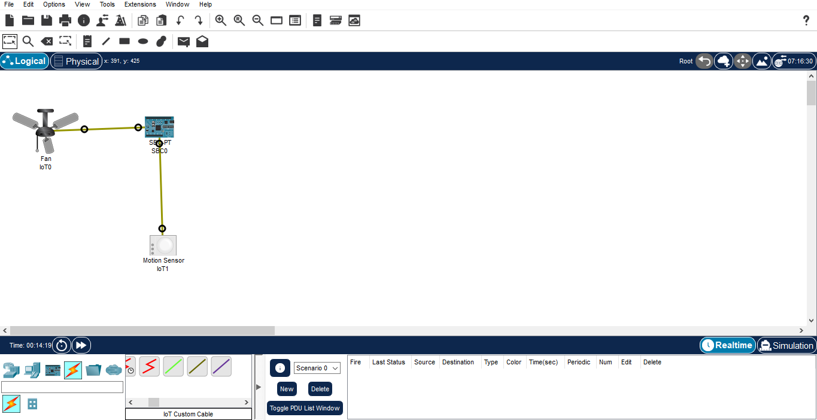

**Step 3:** 1) Now click on SBC Board go to Programming then Select New, select Template

Empty-Python then click on Create

2) Click on main.py file then write code

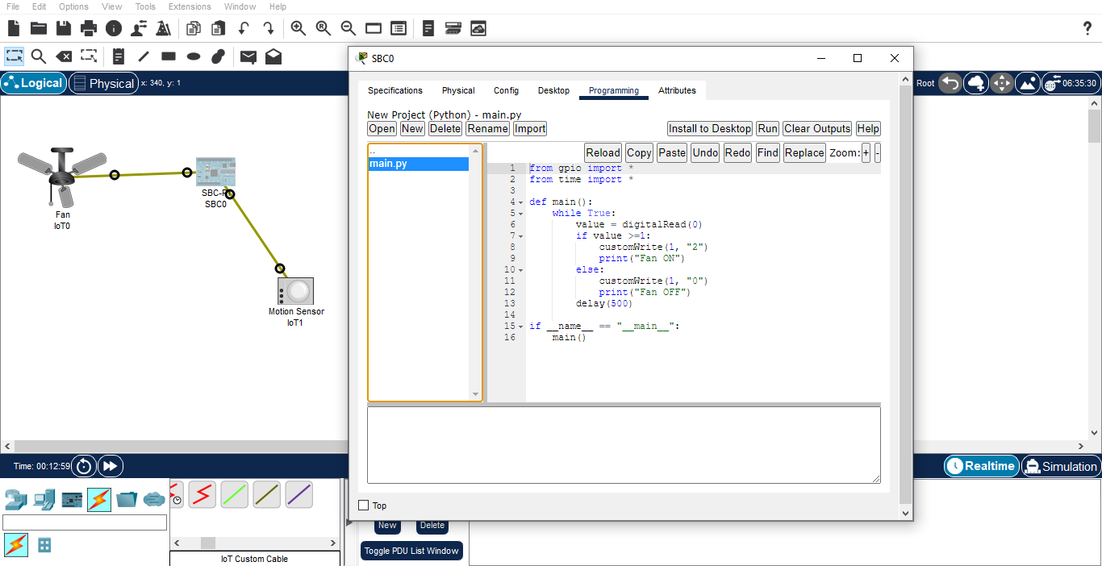

**Code :-**

from gpio import *

from time import *

def main():

while True:

value = digitalRead(0)

if value >=1:

customWrite(1, "2")

print("Fan ON")

else:

customWrite(1, "0")

print("Fan OFF")

delay(500)

if __name__ == "__main__":

main()

**Step 4 :** 1) Click on Run

